**Supplementary data Table S1:**

Supp Table S1

**Table S1**: Primers used to amplify Oak1, UBI and NOS in the construction of pCAMBIA-Oak 1

|  |  |
| --- | --- |
| Primer | Sequence (5’-3’) |
| *Sac*1Oak_F | 5’-ACGGAGCTCATGGCTAAGTTCAC-3’ |
| Oak*Hind*III_R | 5’-ACGAAGCTTTATGCGGCCAAACTAG-3’ |
|  |  |

**Supplementary data Figure S1:**

Supp Fig. S1(a)

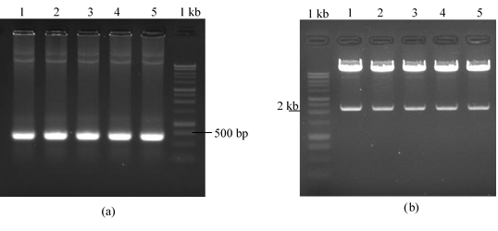

a

Supp Fig. S1(b)

b

**Fig. S1** Confirmation of transgenes in pCAMBIA1301.2 by PCR and double restriction enzyme digestions. A) The presence of the 380 bp Oak 1 gene was confirmed using gene-specific primers from five T-DNA vectors isolated from E. coli (Lane 1-5 indicates isolated colonies). B) An inhibitory enzyme digestion test using SacI and EcoRI enzymes confirmed the orientation of the Oak 1 gene inserted in the T-DNA construct (Lane 1: pCAMBIA-Oak1-3, pCAMBIA-Oak1-6, pCAMBIA-Oak1-9, pCAMBIA-Oak1-14 and pCAMBIA-Oak1-15).