Supplement 1. Workflow of spectra analysis using MZMine 3.4

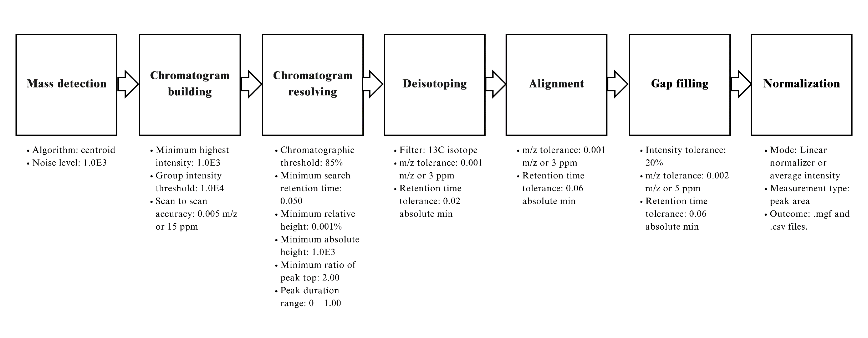

Supplement 2. Permutation validation test was carried out through MetaboAnalyst v6.0 on PLS-DA result confirming the validity of the analysis with data overfitting

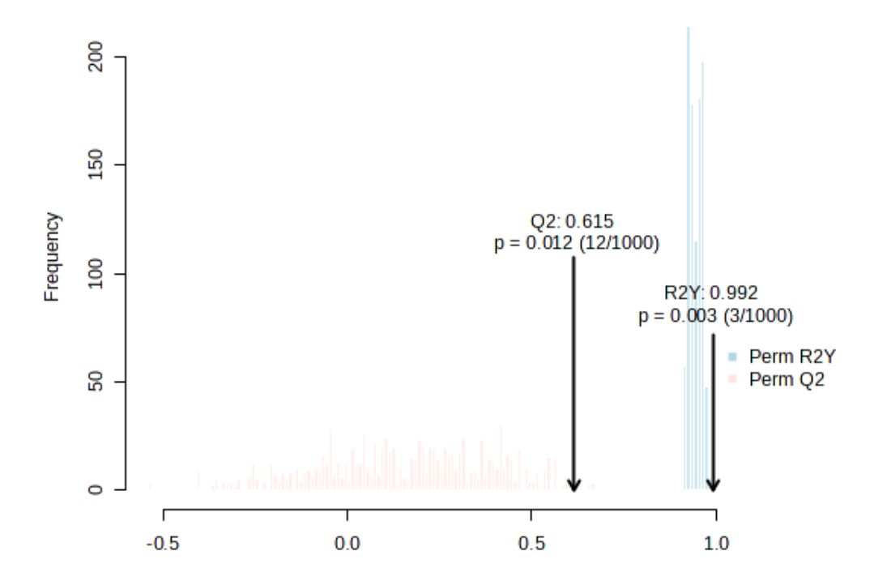
Supplement 3. Permutation validation test was carried out through MetaboAnalyst v6.0 on OPLS-DA result confirming the validity of the analysis with no data overfitting with the valid model
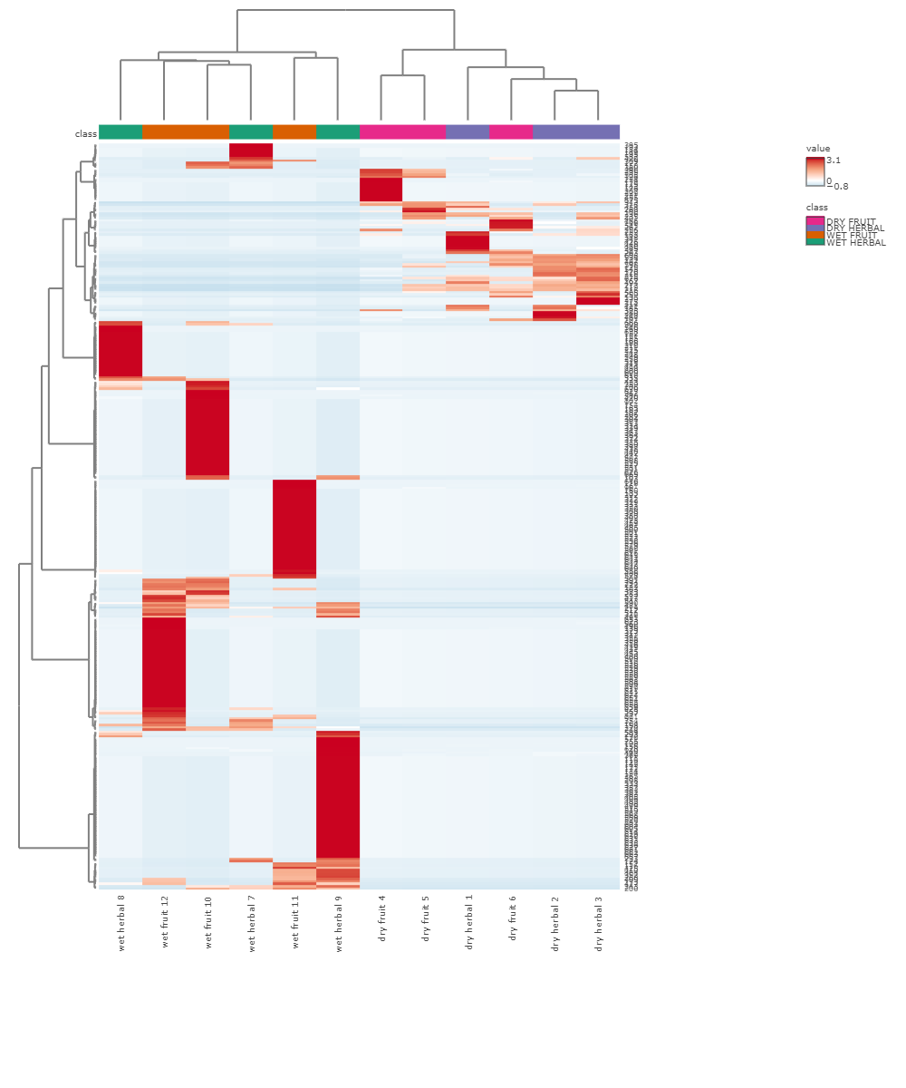
Supplement 4. Heatmap of all 12 H. itama bee bread samples (ungrouped)

